

NOVAC TECHNOLOGY SOLUTIONS

User Manual

Document Version No.: 1.00

Revision History
Version No | Reason For Changes | Author | Approver
0.01 | Draft | Anurag Kumar
1.00 | Reviewed & Approved the User Manual | Anurag Kumar | NIJANTHAN PL

Table of Contents
1. Introduction 4

2. QR Code in COC Document 4

Introduction

As per the requirement, System should display the QR code in the COC (Confirmation of Cover) document of policy schedule.
- Guidelines, circulars, instructions and directions released from time to time by Philippines Insurance council.

1.1 Functional Overview

System is expected to display the QR code when generate the IPA policy schedule.

QR Code in COC Document

- System should display the QR Code in the COC (Confirmation of Cover) page of policy schedule when generating the Policy schedule document.

- System should display the below information when scanning the QR Code.
- COC Number
- Policy Number
- Assured’s Name
- Date of Birth
- Period of Coverage

- Download the IPA policy schedule and scan the QR code.
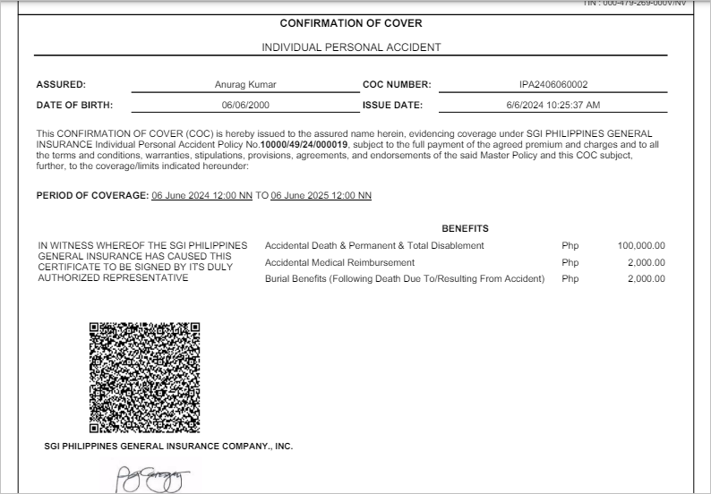

Click on Close button to close the window.

